Savitribai Phule Pune University सावित्रीबाईफु लेपणेविद्यापीठु



# “Hostel Management System”

GUIDED BY

**Mrs. Reena More**

SUBMITTED BY

**1. Darshan Jagtap**

**2. Pushkar Patil**

**3. Aradhy Shinde**

**4. Vaibhav Bhamare**

T.Y.B. Sc (COMPUTER SCIENCE)

During Academic Year 2022-2023

Department of Computer Science



**MGV’s**

**Panchanvati College of Management & Computer Science,**

### Nashik-03

**C E R T I F I C A T E**

This is to certify that Mr. Darshan Jagtap , Mr. Pushkar Patil

Mr. Aradhy Shinde &Mr. Vaibhav Bhamare T.Y.B. Sc (Computer Science) has satisfactorily completed the project work on topic “**Hostel Management System**” In partial fulfilment of Bachelor of Computer Science in the academic year 2022-23 as per the requirement of the university of the Savitribai Phule Pune University.

**Project Guide Head Of Comp.Sci.**

**Mrs. Reena More Mrs. Chetana Desale**

**Internal Examiner External Examiner**

# ACKNOWLEDGEMENT

Here we gladly present this project report on **“ONLINE**

**HOSTEL MANAGEMENT SYSTEM”** as part of the 6th semester B.TECH in Computer

Science and Engineering. At this time of submitting this report we use this opportunity to mention those people who with us along the work. We take this occasion to thank God, almighty for blessing us with his grace and taking our endeavour to a successful culmination. We extend our sincere and heartfelt thanks to our esteemed ***guide,*** ***Mrs.Preetha.S*** for providing us with the right guidance and advice at the crucial junctures and for showing us the right way. We extend our sincere thanks to our respected ***Head Of the Division Mr. Pramod Pavithran***, for allowing us to use the facilities available. We would like to thank the other faculty members also, at this occasion. Last but not the least; we would like to thank friends for the support and encouragement they have given us during the course of our work.

Submitted by

**RESHMI RADHAKRISHNAN**

**RINSHA P.A**

**ROOPASREE R**

# ABSTRACT

“ONLINE HOSTEL MANAGEMENT SYSTEM” is software developed for managing various activities in the hostel. For the past few years the number of educational institutions is increasing rapidly. Thereby the number of hostels is also increasing for the accommodation of the students studying in this institution. And hence there is a lot of strain on the person who are running the hostel and software’s are not usually used in this context. This particular project deals with the problems on managing a hostel and avoids the problems which occur when carried manually. Identification of the drawbacks of the existing system leads to the designing of computerized system that will be compatible to the existing system with the system which is more user friendly and more GUI oriented. We can improve the efficiency of the system, thus overcome the drawbacks of the existing system.

## LIST OF FIGURES

3.1 DFD for hostel management system 17

3.2 DFD for student module 17

3.3 DFD for registration purpose 18

3.4 DFD for sec module 18

3.5 DFD for admin module 19

3.6 DFD vacation purpose 20

# LIST OF TABLES

3.1 Database table for student application 22

3.2 Database table for mess fee calculation 23

3.3 Database table for fee payment status 23

3.4 Database table for student vacation register 24

## LIST OF ABBREVIATIONS

1. DFD - Data Flow Diagram
2. GUI -Graphical User Interface

**TABLE OF CONTENTS**

**ABSTRACT i**

**LIST OF TABLES ii**

**LIST OF FIGURES iii**

**LIST OF SYMBOLS iii**

1. **INTRODUCTION 07**

1.1 PROJECT OVERVIEW 07 1.2.PROJECT OBJECTIVES 08

### **2. SYSTEM ANALYSIS** 09

2.1 EXISTING SYSTEM 09

### 2.2PROPOSED SYSTEM 10

1. **FEASIBILITY STUDY 11** 
   1. TECHNICAL FEASIBILITY 11 3.2 ECONOMIC FEASIBILITY 11 3.3 OPERATIONAL FEASIBILITY 12
2. **REQUIREMENT ANALYSIS AND SPECIFICATION 13** 
   1. HARDWARE CONFIGURATION 13
   2. SOFTWARE CONFIGURATION 14
3. **SYSTEM DESIGN 14**

### 5.1APPLICATION OVERVIEW 15

5.2DATAFLOW DIAGRAM 20 DATABASE DESIGN (TABLE STRUCTURE)

1. **SYSTEM IMPLEMENTATION STRUCTURE 23**

6.1 SYSTEM IMPLEMENTATION

TESTING 24

1. **CONCLUSION 26**

### REFERENCES 27 **APPENDIX 28**

1. **SOURCE CODE 28**
2. **SAMPLE SCREEN SHOT 44**

### ***CHAPTER 1**INTRODUCTION***

**PROJECT OVERVIEW**

The online hostel management system is web based software to provide college students accommodation to the university hostel more efficiently. This project also keeps details of the hostellers and applied students. It is headed by Warden. He will be the administrator. For accommodate a large number of students into hostel.

This document is intended to minimize human works and make hostel allocation is an easier job for cusat students and hostel authorities by providing online application for hostel, automatically select the students from the waiting list and mess calculation, complaint registration, notice board etc. etc. Students will get approval notification in their mails. Hostellers can view notice board, hostel fee, mess menu by login into the online system.

#### PROJECT OBJECTIVES

* Maintain the students as hostellers and waiting list students separately
* Process allotment list.
* Admin can send the approval notification to every approved student via email .
* Automatically insert student’s details to the hosteller’s record when the allotment is confirmed by the admin and deleted when vacation is conformed or after the course end date.
* Students can register their complaints.
* Admin can edit notice board and each student can view it.
* Hostel secretary can calculate hostel fee including mess fee and can edit mess menu
* Hostellers can check the status of every month’s hostel fee

***CHAPTER 2***

***SYSTEM ANALYSIS* EXISTING**

**SYSTEM**

The existing system is manual based and need lot of efforts and consume enough time. In the existing system we can apply for the hostels online but the allotment processes are done manually. It may lead to corruptions in the allocation process as well as hostel fee calculation. The existing system does not deals with mess calculation and complaint registration.

DISADVANTAGES:

* More human power
* More strength and strain of manual labour needed
* Repetition of same procedure.
* Low security.
* Data redundancy.
* Difficulty to handle.
* Difficulty to update data.

Record keeping is difficult.

* Backup data can be easily generated.

##### PROPOSED SYSYTEM

The proposed system is having many advantages over the existing system. It require less overhead and very efficient. The proposed system deals with the mess calculation and allotment process efficiently.

***CHAPTER 3***

***FEASIBILITY STUDY***

### **TECHNICAL FEASIBILITY**

The technical feasibility in the proposed system deals with the technology used in the system. It deals with the hardware and software used in the system whether they are of latest technology or not. It happens that after a system is prepared a new technology arises and the user wants the system based on that technology. This system use windows platform, .net as front end technology and sql server as backend technology. Thus ONLINE HOSTEL MANAGEMENT

SYSTEM is technically feasible.

### **ECONOMICAL FEASIBILITY**

Economic analysis is the most frequently used method for evaluating the effectiveness of a new system. More commonly known as cost/benefit analysis. .net using visual C# and sql datdabase easily available in internet

### **OPERATIONAL FEASIBILITY**

The project has been developed in such a way that it becomes very easy even for a person with little computer knowledge to operate it. This software is very user friendly and does not require any technical person to operate .Thus the project is even operationally feasible.

**REQUIREMENT ANALYSIS AND SPECIFICATION**

Functions and features delivered to the end users

The end users of the proposed system are:

**Administrator module:**

In administrator module administrator manages the master data’s like server details and student details. Accept the application of students, view the application forms, reject the fake applications, view the complaints of the students in the hostel, accept the vacating form and delete from the database, edit the notice boards and view complaints.

**Student Module:**

In student module, they can Submit application form, change password, can check status, view notice board, view monthly hostel fee and submit the vacating form.

#### Secretary Module

In secretary module, the secretary can calculate the mess bill, and edit the mess menu, view the notice board and also change the password.

### **HARDWARE CONFIGURATION**

The section of hardware configuration is an important task related to the software development insufficient random access memory may affect adversely on the speed and efficiency of the entire system. The process should be powerful to handle the entire operations. The hard disk should have sufficient capacity to store the file and application.

|  |  |  |
| --- | --- | --- |
| Processor | :Pentium IV and above | |
| Processor speed | : 1.4 GHz Onwards | |
| System memory | : 128 Mb minimum 256 Mb recommended | |
| Cache size | : 512 KB | |
| RAM | : 512 MB(Minimum) | |
| Network card | : Any card can provide a 100mbps speed | |
| Network connection | : UTP or Coaxile cable connection | |
| Printer | : Inkjet/Laser Color printer provides at least 1000 Dpi | |
| Hard disk | : 80Gb | |
| Monitor | : SVGA Color 15” | |
| Mouse | : 104 keys US Key Serial, USB or PS/2 |
| Modem | : 56.6 Kbps |

### 

### **SOFTWARE CONFIGURATION**

A major element in building a system is the section of compatible software since the software in the market is experiencing in geometric progression. Selected software should be acceptable by the firm and one user as well as it should be feasible for the system.

This document gives a detailed description of the software requirement specification. The study of requirement specification is focused specially on the functioning of the system. It allow the developer or analyst to understand the system, function to be carried out the performance level to be obtained and corresponding interfaces to be established.

|  |  |
| --- | --- |
| Front end tool | : ASP.net with C# as scripting language |
| Backend | : Microsoft SQL Server 2008 |
| Operating system | : Windows 2007/2008 |
| Client Side | : HTML, Photoshop |

***CHAPTER 4***

#### *SYSTEM DESIGN*

The system design is divided in to three portions. The Administrator section ,hostel secretary section and student section

.

##### 1 Administrator

1. The Administrator can allot different students to the different hostels.
2. He can vacate the students for the hostels.
3. He can control the status of the fee payment.
4. He can edit the details of the students. He can change their rooms, edit and delete the student records.

5.He can edit the news board

6.He can check the complaints

2. **The Hostel Secretary** can :

1. Make the Mess menu
2. Make the mess bill & hostel bill

3.Give notifications in Notice Board

. In input data design, we design the source document that capture the data and then select the media used to enter them into the computer.

There are two major approaches for entering data in to the computer. They are · Menus.

· Dialog Boxes.

### **DATAFLOW DIADRAMS**

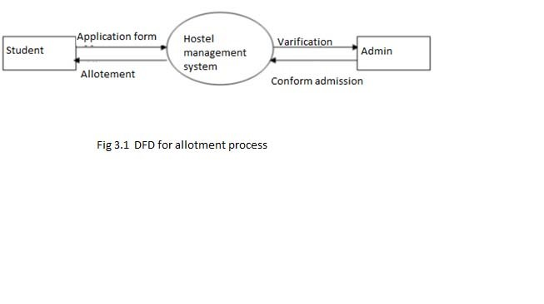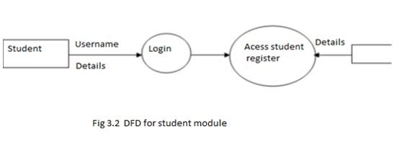

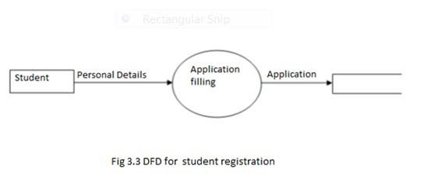

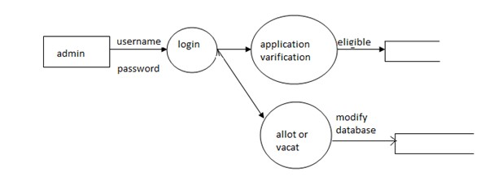

Fig 3.4 DFD for Admin module

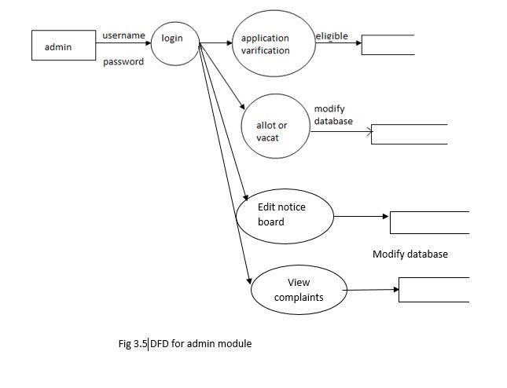

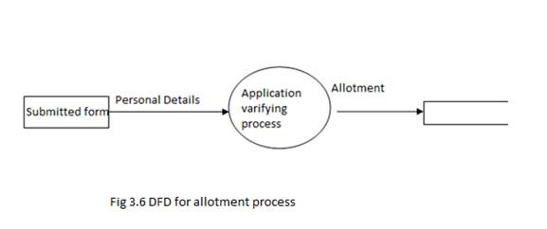

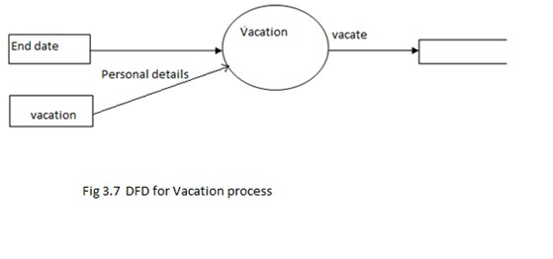

### **DATABASE DESIGN (TABLE STRUCTURE)**

|  |  |
| --- | --- |
| NAME | TYPE |
| NAME | VARCHAR |
| GENDER | VARCHAR |
| DOB | DATE |
| ADDRESS | NCHAR |
| PINCODE | INT |
| DISTRICT | VARCHAR |
| LANDLINE NUMBER | INT |
| MOBILE NUMBER | INT |
| NAME &ADDRESS OF PARENT OR GUARDIAN | NCHAR |
| PARENT’S PHONE NUMBER | INT |
| EMAIL ID | NCHAR |
| RELIGION | VARCHAR |
| CAST | VARCHAR |
| DISTANCE IN KILOMETER | FLOAT |
| COMMUNAL RESERVATION | CHAR |
| PHYSICALLY HANDICAPPED | CHAR |
| FOREIGN STUDENT | CHAR |
| COURSE OF STUDY | CHAR |
| NATURE OF STUDY | NCHAR |
| DEPARTMENT | NCHAR |
| DATE OF ADMISSION TO COURSE | DATE |
| EXPECTED DATE OF COMPLETION OF COURSE | DATE |
| DATE FROM ADMISSION REQUIRES | DATE |
| FELLOWSHIPS ANY RECIEVED | CHAR |
| FELLOWSHIP DETAILS | VARCHAR |
| PHOTO | IMAGE |
| SIGN | IMAGE |
| THUMP IMPRESSION | IMAGE |
| USERNAME | NCHAR |
| PASSWORD | NCHAR |
| CONFORM PASSWORD | NCHAR |

Table 3.1 Database table for student application

MESS FEE CALCULATION

|  |  |
| --- | --- |
| NAME | TYPE |
| DEPARTMENT | VARCHAR |
| STUDENTNAME | VARCHAR |
| COST PER DAY | FLOAT |
| NO OF DAYS | INT |
| RENT | FLOAT |
| HOSTELFEE | FLOAT |

PAYMENT STATUS

|  |  |
| --- | --- |
| NAME | TYPE |
| DEPARTMENT | VARCHAR |
| STUDENT NAME | VARCHAR |
| STATUS | CHAR |

Table 3.3 Database table for fee payment status

#### Vacation

|  |  |
| --- | --- |
| NAME | TYPE |
| NAME | VARCHAR |
| DEPARTMENT | VARCHAR |
| YEAR | VARCHAR |
| CS_STUDY | VARCHAR |
| DATESUB | CHAR |
| DATEREL | CHAR |
| REASON | VARCHAR |
| USERNAME | VARCHAR |

Table 3.4 Database table for students vacation register

***CHAPTER 5 SYSTEM IMPLEMENTATION AND TESTING***

#### SYSTEM IMPLEMENTATION

Implementation is the stage in the project where the theoretical design is turned into a working system and is giving confidence on the new system for the users that it will work efficiently and effectively. It involves careful planning, investigation of the current system and its constraints on implementation, design of methods to achieve the change over, an evaluation of change over methods. Apart from planning major task of preparing the implementation are education and training of users. The implementation process begins with preparing a plan for the implementation of the system. According to this plan, the activities are to be carried out, discussions made regarding the equipment and resources and the additional equipment has to be acquired to implement the new system. In network backup system no additional resources are needed. Implementation is the final and the most important phase. The most critical stage in achieving a successful new system is giving the users confidence that the new system will work and be effective. The system can be implemented only after thorough testing is done and if it is found to be working according to the specification. This method also offers the greatest security since the old system can take over if the errors are found or inability to handle certain type of transactions while using the new system.

##### *CHAPTER 6 SYSTEM TESTING*

As the part of system testing we execute the program with the intent of finding errors and missing operations and also a complete verification to determine whether the objectives are met and the user requirements are satisfied. The ultimate aim is quality assurance.

Tests are carried out and the results are compared with the expected document. In the case of erroneous results, debugging is done. Using detailed testing strategies a test plan is carried out on eachmodule. The various tests performed are unit testing, integration testing and user acceptance testing.

###### Unit Testing

The software units in the system is are modules and routines that are assembled and integrated to perform a specific function. As a part of unit testing we executed the program for individual modules independently. This enables, to detect errors in coding and logic that are contained within each of the three module. This testing includes entering data that is filling forms and ascertaining if the value matches to the type and entered into the database. The various controls are tested to ensure that each performs its action as required.

###### Integration Testing

Data can be lost across any interface, one module can have an adverse effect on another, sub functions when combined, may not produce the desired major functions. Integration testing is a systematic testing to discover errors associated within the interface. The objective is to take unit tested modules and build a program structure. All the modules are combined and tested as a whole. Here the admin module, sec module and student module options are integrated and tested. This testing provides the assurance that the application is well integrated functional unit with smooth transition of data.

###### User Acceptance Testing

User acceptance of a system is the key factor for the success of any system. The system under consideration is tested for user acceptance by constantly keep the records of applicants and making changes to the details and password whenever required.

###### CONCLUSION

To conclude the description about the project The project, developed using ASP.net with c# and SQL SERVER is based on the requirement specification of the user and the analysis of the existing system, with flexibility for future enhancement.

ONLINE HOSTEL MANAGEMENT SYSTEM is very useful for hostel allotment and mess fee calculation . This hostel management software is designed for people who want to manage various activities in the hostel. For the past few years the numbers of educational institutions are increasing rapidly. Thereby the numbers of hostels are also increasing for the accommodation of the students studying in this institution. And hence there is a lot of strain on the person who are running the hostel and software’s are not usually used in this context. This particular project deals with the problems on managing a hostel and avoids the problems which occur when carried manually.

Identification of the drawbacks of the existing system leads to the designing of computerized system that will be compatible to the existing system with the system which is more user friendly and more GUI oriented.

REFERENCE

1. James R Groff and Paul N Weinberg, “Complete reference SQL”. Second Edition
2. Agnes Molnar and Adam Granicz , “ .Net with Visual C# 2010”.
3. Css files, from W3 schools. http//w3 school.com/css_file [4] Hostel form, from cusat hostel.

http//cusat.ac.in/hostel_form

[5] Css files, from Wikipedia, the free encyclopedia. http://www.en.wikipedia.org/wiki/Wireless_security.

`